Minor Spherical Sector
# Source: AI Source: Provided by: [Data Path: Persons Table -> ID Column: 1, Name_En Column: Motasem Essam] -> From: [ChatGPT] on [7/25/2026]
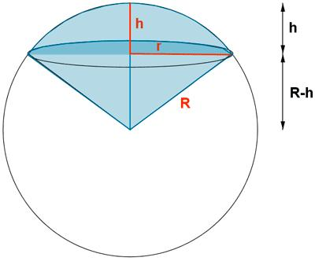

Definition
# Source: AI Source: Provided by: [Data Path: Persons Table -> ID Column: 1, Name_En Column: Motasem Essam] -> From: [ChatGPT] on [7/25/2026]
A minor spherical sector is the smaller portion of a solid sphere enclosed by a spherical cap and the conical surface connecting the cap's circular boundary to the sphere's center.
It consists of a spherical cap together with the cone-like region extending from the sphere's center to the cap's circular boundary. The defining feature is that the sector corresponds to the smaller spherical cap, whose height is less than the sphere's radius.
For a sphere of radius $R$, the cap height $h$ of a minor spherical sector satisfies
$$0<h<R$$

Simple Definition
# Source: AI Source: Provided by: [Data Path: Persons Table -> ID Column: 1, Name_En Column: Motasem Essam] -> From: [ChatGPT] on [7/25/2026]
A minor spherical sector is the smaller solid region formed by a spherical cap and the cone extending from the sphere's center to the cap's circular edge.

Geometric Elements
# Source: AI Source: Provided by: [Data Path: Persons Table -> ID Column: 1, Name_En Column: Motasem Essam] -> From: [ChatGPT] on [7/25/2026]
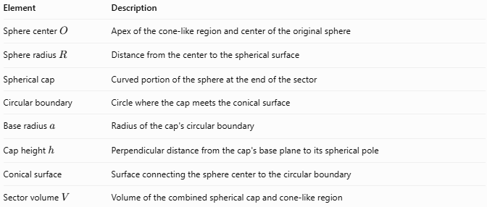
Element | Description
Sphere center $O$ | Apex of the cone-like region and center of the original sphere
Sphere radius $R$ | Distance from the center to the spherical surface
Spherical cap | Curved portion of the sphere at the end of the sector
Circular boundary | Circle where the cap meets the conical surface
Base radius $a$ | Radius of the cap's circular boundary
Cap height $h$ | Perpendicular distance from the cap's base plane to its spherical pole
Conical surface | Surface connecting the sphere center to the circular boundary
Sector volume $V$ | Volume of the combined spherical cap and cone-like region

Mathematical Properties and Formulas
# Source: AI Source: Provided by: [Data Path: Persons Table -> ID Column: 1, Name_En Column: Motasem Essam] -> From: [ChatGPT] on [7/25/2026]
Let:
- $R$ = radius of the sphere
- $h$ = height of the associated spherical cap
- $a$ = radius of the circular boundary
- $V$ = volume of the spherical sector

Minor-Sector Condition
# Source: AI Source: Provided by: [Data Path: Persons Table -> ID Column: 1, Name_En Column: Motasem Essam] -> From: [ChatGPT] on [7/25/2026]
$$\boxed{0<h<R}$$
The sector corresponds to a cap smaller than a hemisphere.

Circular Boundary Radius
# Source: AI Source: Provided by: [Data Path: Persons Table -> ID Column: 1, Name_En Column: Motasem Essam] -> From: [ChatGPT] on [7/25/2026]
From the right triangle formed by the sphere radius and the perpendicular distance to the base plane:
$$\boxed{a=\sqrt{2Rh-h^{2}}}$$

Volume of the Spherical Cap
# Source: AI Source: Provided by: [Data Path: Persons Table -> ID Column: 1, Name_En Column: Motasem Essam] -> From: [ChatGPT] on [7/25/2026]
The cap portion has volume
$$V_{\text{cap}}=\frac{πh^{2}}{3}\left(3R-h\right)$$

Volume of the Cone-Like Portion
# Source: AI Source: Provided by: [Data Path: Persons Table -> ID Column: 1, Name_En Column: Motasem Essam] -> From: [ChatGPT] on [7/25/2026]
The cone has base radius $a$ and height $R-h$, measured from the sphere center to the cap's base plane for a minor cap:
$$V_{\text{cone}}=\frac{1}{3}πa^{2}\left(R-h\right)$$

Total Spherical Sector Volume
# Source: AI Source: Provided by: [Data Path: Persons Table -> ID Column: 1, Name_En Column: Motasem Essam] -> From: [ChatGPT] on [7/25/2026]
The spherical sector consists of the cap plus the cone-like portion. Combining the two volumes gives the standard spherical-sector formula:
$$\boxed{V=\frac{2}{3}{πR}^{2}h}$$
This formula is valid for the minor sector and, with the appropriate cap height, for the major sector as well.

Worked Example
# Source: AI Source: Provided by: [Data Path: Persons Table -> ID Column: 1, Name_En Column: Motasem Essam] -> From: [ChatGPT] on [7/25/2026]
A sphere has radius $R=5\text{ cm}$, and its minor spherical sector has cap height $h=2\text{ cm}$. Calculate the circular boundary radius and sector volume.
Given
$$R=5\text{ cm}, h=2\text{ cm}$$
Step 1 — Confirm the sector type
$$0<2<5$$
Therefore, it is a minor spherical sector.
Step 2 — Calculate the circular boundary radius
$$\begin{aligned}a&=\sqrt{2Rh-h^{2}} \\ &=\sqrt{2\left(5\right)\left(2\right)-2^{2}} \\ &=\sqrt{16}=4\end{aligned}$$
$$\boxed{a=4\text{ cm}}$$
Step 3 — Calculate the sector volume
$$\begin{aligned}V&=\frac{2}{3}{πR}^{2}h \\ &=\frac{2}{3}π\left(5^{2}\right)\left(2\right) \\ &=\frac{100π}{3}\end{aligned}$$
$$\boxed{V≈104.72{\text{ cm}}^{3}}$$

Comparison with Related Solids
# Source: AI Source: Provided by: [Data Path: Persons Table -> ID Column: 1, Name_En Column: Motasem Essam] -> From: [ChatGPT] on [7/25/2026]
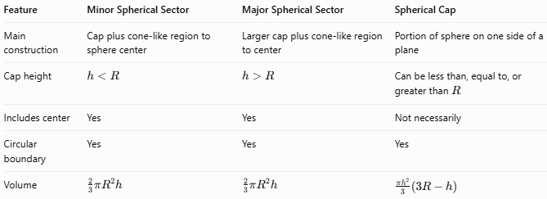
Feature | Minor Spherical Sector | Major Spherical Sector | Spherical Cap
Main construction | Cap plus cone-like region to sphere center | Larger cap plus cone-like region to center | Portion of sphere on one side of a plane
Cap height | $$h<R$$ | $$h>R$$ | Can be less than, equal to, or greater than $R$
Includes center | Yes | Yes | Not necessarily
Circular boundary | Yes | Yes | Yes
Volume | $$\frac{2}{3}{πR}^{2}h$$ | $$\frac{2}{3}{πR}^{2}h$$ | $$\frac{πh^{2}}{3}\left(3R-h\right)$$

Applications
# Source: AI Source: Provided by: [Data Path: Persons Table -> ID Column: 1, Name_En Column: Motasem Essam] -> From: [ChatGPT] on [7/25/2026]
- Geometry: Studying the relationship between spherical caps, cones, and spheres.
- Engineering: Estimating the volume of spherical components with sector-shaped geometry.
- Computer graphics: Modeling and rendering portions of spheres.
- Architecture: Designing curved spherical structures and dome sections.
- Mathematics education: Comparing spherical sectors with ordinary conical sectors.

Key Points
# Source: AI Source: Provided by: [Data Path: Persons Table -> ID Column: 1, Name_En Column: Motasem Essam] -> From: [ChatGPT] on [7/25/2026]
- A minor spherical sector is associated with a spherical cap whose height is less than the sphere radius.
- It includes the spherical cap and the cone-like region extending to the sphere center.
- Its circular boundary radius is $a=\sqrt{2Rh-h^{2}}$.
- Its volume is $\frac{2}{3}{πR}^{2}h$.
- A spherical sector is different from a spherical cap: the sector includes the region connecting the cap's circular boundary to the sphere center.
- The minor and major classifications depend on the height of the associated cap.

Conclusion
# Source: AI Source: Provided by: [Data Path: Persons Table -> ID Column: 1, Name_En Column: Motasem Essam] -> From: [ChatGPT] on [7/25/2026]
A Minor Spherical Sector is a solid formed by a minor spherical cap and the cone-like region connecting its circular boundary to the center of the sphere. Its cap height is less than the sphere radius, and its volume can be calculated directly from the sphere radius and cap height.

